HC & HH Districts NQ Series
Hoosier Crossroads Debate and Congress
Hoosier Heartland Debate (no Congress)
January 24, 2026 - Carmel High School
UPDATE 01/19/26
- NEW! UPDATED Schedule. We are watching the weather closely for this weekend. We consulted with schools that have to travel the furthest and confirmed that an earlier start is doable for them. So, we will start Registration at 7:30am, will hold the Judges' Meeting at 8:00am, and start Round 1 at 8:30am. We will run this tournament as efficiently as possible. Each team verifying that their (1) entries and (2) judges are entered in correctly (always enter your school's district) will help avoid some of the delays and challenges that we had last year. JD will prepare an updated schedule and will post the same, but everyone knows that a Districts schedule is little more than an educated guess. It will definitely change as the tournament progresses.
- Entry numbers. We have some pretty healthy numbers. For Debate to have NQ, we must have atleast 4 entries + 2 schools in a category. I share this because drops are a real possibility given the approaching weather and flu season, and everyone needs to understand what a drop or missing school will do for particular categories for NQ. Here are the entry numbers:
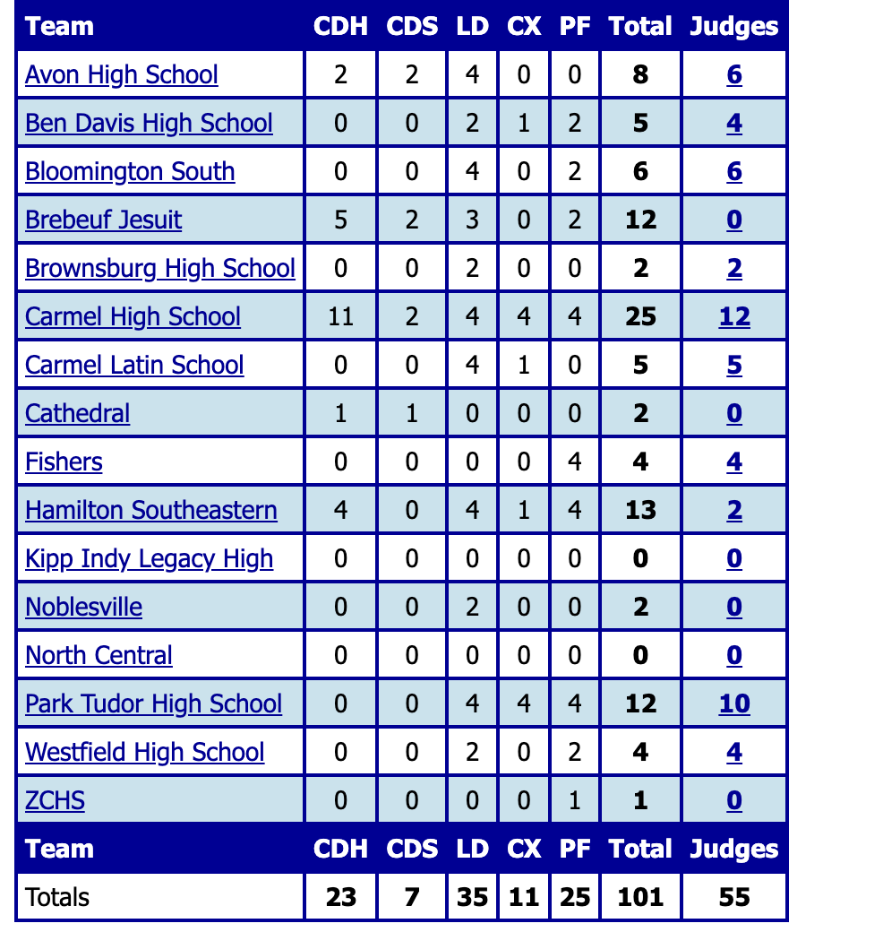
HC House - 23 entries
HC Senate - 7 entries
HC / LD - 17 entries (5 schools)
HH / LD - 18 entries (6 schools)
HC / CX - 5 entries (2 schools)
HH / CX - 6 entries (3 schools)
HC / PF - 15 entries (5 schools)
HH / PF - 10 entries (4 schools)

- REMINDERS.
  - Approaching deadlines.
    - January 19, 2026 - Contestant entry additions are CLOSED. Please reach out to Jeanne and Tony if you have an entry you failed to make on time. We will leave open Judge entry for another day or two.
    - January 23, 2026 - Your Senior contestant names are due to Jeanne Malone.
    - January 23, 2026 - All of your contestants must be registered with and paid for through NSDA.
  - NEW! Correct district - Judges. Please make sure that all of your judges are listed as judges for the district that your school belongs to. I was reminded earlier today that District Debate ran behind schedule last year in part because a school failed to make sure that their judges were marked correctly.
  - Correct district - Contestants. We have had in years past schools that accidentally signed contestants up for the wrong district. We discovered one such instance last year after Round 1 and had to re-run the entire first round of a HC debate category. We will do our best to run this tournament as efficiently as possible, but that kind of a mistake will delay operations. Please, please go into SW right now and make sure that all of your entries are registered under the correct district.
  - Traveling trophies. Schools with NQ'ers from last year need to confirm that their traveling trophies have been engraved and bring them to Districts this Saturday!
  - Checks. We are charging $2/entry this year. This charge is necessary given to partially offset the Districts' annual costs (NQ plaques, ribbons, stipends for hosting schools to cover costs, etc.). Please bring checks to Registration at Districts. For those in HH, please make checks payable to "Hoosier Heartland District". NEW! Jeannie has indicated that we will accept cash at the Registration Table for Entry Fees.

- tony fehrenbacher

